Experiment : 5
Date:
CLASS DIAGRAM AND TIME SEQUENCE
Aim:
To apply software engineering principles by implementing the class diagram and time sequence diagram

Class diagram

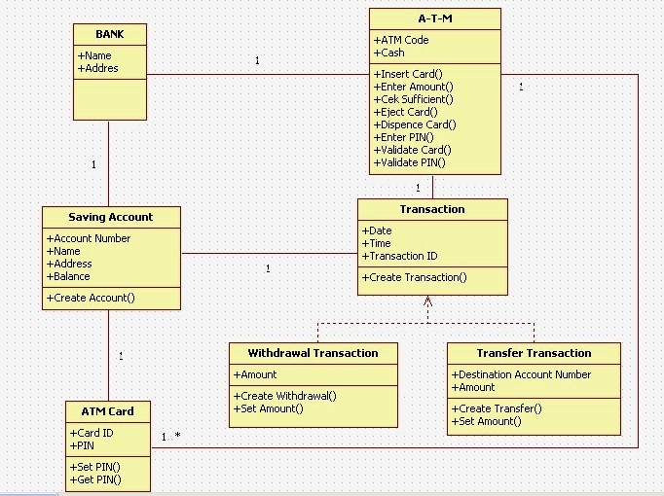

Time sequence diagram 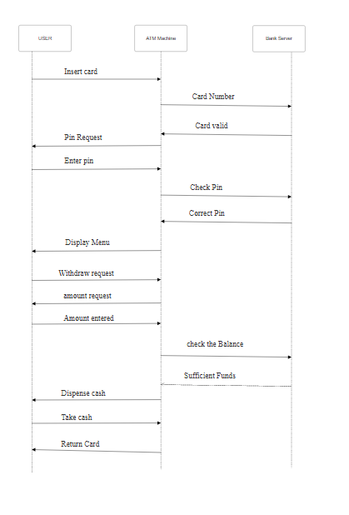
Conclusion:
This experiment proves that Software Engineering principles by designing these diagrams to represent system architecture and behavioral flow.

